

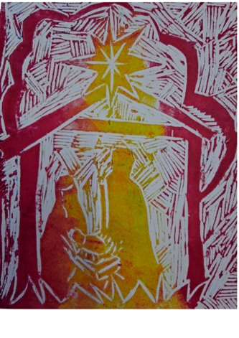
Christmas
Holy Communion

Welcome

A warm welcome as we gather to celebrate the joy of Christmas; of ‘the Word made flesh.’ During these 12 days of Christmas we ‘ponder in our hearts’ the wonder that God comes to earth in human form. A special welcome if you are a visitor and staying with family and friends over this festive season. We do hope you feel at home, the stewards wearing rainbow lanyards, will be happy to help you.

Our services are often live streamed, so those at home can worship with us. If you wish to ensure you are not seen on camera please sit on the right hand side of the church as you enter, please ask a steward if you are unsure. The cameras do not film people coming up for communion.

Children are always welcome in church and we understand that they do not always find it easy to be quiet! Please move around as you need to with them and if toddlers need a wander that is fine as long as they remain under your supervision. Church buildings are great places to explore but please be mindful of uneven floors, sharp edges and candles.
If you receive communion in any church you are welcome to receive the bread and wine here. If you need a gluten free wafer or wish to receive communion in your seat please let one of the stewards know.

We are part of the Inclusive Church network and as such we seek to challenge the church where it continues to discriminate against people on grounds of disability, economic power, ethnicity, gender, gender identity, learning disability, mental health, neurodiversity, or sexuality. We believe in a Church which welcomes and serves all people in the name of Jesus Christ; which is scripturally faithful; which seeks to proclaim the Gospel afresh for each generation; and which, in the power of the Holy Spirit, allows all people to grasp how wide and long and high and deep is the love of Jesus Christ. We are a work in progress and welcome anyone who wishes to journey with us.

More information can be found at:
www.allsaintsloughborough.org.uk



The Welcome

Before the service begins there is an informal welcome. Once the service starts please join in with the words in bold type. The parts in red are instructions or an indication of what is happening. You will find throughout the service there are notes to stand, sit or kneel. These are invitations not commands, so please do whatever helps you to worship.

The Gathering

Processional Hymn

All stand to sing the hymn as the music begins and the servers and ministers process.

The Greeting
Grace, mercy and peace
from God our Father
and the Lord Jesus Christ
be with you.
and also with you.

The Word was made flesh, and dwelt among us
and we beheld his glory.

Additional words of welcome from the president may be given and the theme of the service introduced.

Prayers of Penitence at the Advent Wreath

The deacon or lay assistant invites us to confess our sins, you may wish to kneel.

As we kneel with the shepherds before the new-born Christ child,
we open our hearts in penitence and faith.

Silence is kept and the final candle on the advent wreath is lit

God our Father,
you sent your Son full of grace and truth:
forgive our failure to receive him.
Lord, have mercy,
Lord, have mercy.

Jesus our Saviour,
you were born in poverty and laid in a manger:
forgive our greed and rejection of your ways.
Christ have mercy,
Christ have mercy,

Spirit of Love,
your servant Mary responded joyfully to your call:
forgive the hardness of our hearts.
Lord, have mercy,
Lord, have mercy,

After a short silence the president says the prayer of absolution.

May God of all healing and forgiveness
draw you to himself
and cleanse you from all your sins,
that you may behold the glory of his Son,
the Word made flesh, Jesus Christ our Lord.
Amen.

We remain seated to sing together the final verse of our Advent Wreath hymn

Advent candles tell their story
on this Christmas Day.
Those who waited for God’s glory:
they prepared the way.
Christ is with us: loving, giving,
in us living, here today!

Gloria in Excelsis

We stand to sing the ancient hymn of praise in this traditional Peruvian setting

Glory to God, glory to God,
glory to the Father.
Glory to God, glory to God,
glory to the Father.
To God be glory for ever.
To God be glory for ever.
Alleluia, amen,
Alleluia, amen,
Alleluia, amen,
Alleluia, amen

Glory to God, glory to God,
Son of the Father.
Glory to God, glory to God,
Son of the Father.
To God be glory for ever.
To God be glory for ever.
Alleluia, amen,
Alleluia, amen,
Alleluia, amen,
Alleluia, amen

Glory to God, glory to God,
glory to the Spirit.
Glory to God, glory to God,
glory to the Spirit.
To God be glory for ever.
To God be glory for ever.
Alleluia, amen,
Alleluia, amen,
Alleluia, amen,
Alleluia, amen

Words: Peruvian Liturgical Text | Music: PERUVIAN TRADITIONAL CHANT, AM 416,

The Collect

The president introduces a period of silent prayer with the words ‘let us pray’. All remain standing for the period of silence and the collect - the special prayer for the day.

The Liturgy of the Word

Readings

We sit to listen to the reading appointed for the day taken from the Christian scriptures, the Bible. At the end we say

Here ends the reading
Thanks be to God.

Gospel Reading

We stand and sing together the Alleluia as the Gospel book is carried to the middle of the church and the congregation turns to face the reader. The Gospels are the books of the Bible which contain the stories and words of Jesus hence we stand to show how important they are to us.

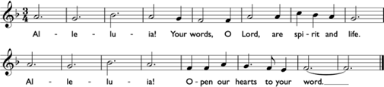

Words: Bernadette Farrell (b. 1957) | Music: GOSPEL GREETING, AM 376,  B. Farrell

(Repeat)

Today a Saviour is born who is Christ the Lord.
God’s Word is with us and lives among us within our world.

Alleluia!
Your words, O Lord, are spirit and life.
Alleluia!
Open our hearts to your word.

(Repeat)
Hear the Gospel of our Lord Jesus Christ according to xx.
Glory to you, O Lord.

At the end of the reading :

This is the Gospel of the Lord.
Praise to you, O Christ.

We sing Alleluia as the gospel is carried back and we sit after the preacher offers an introductory prayer.

Sermon

After the sermon there is a brief pause for reflection and then all stand to affirm the faith of the church.

Affirmation of Faith

Let us declare our faith in God

We believe in God the Father,
from whom every family
in heaven and on earth is named.

We believe in God the Son,
who lives in our hearts through faith,
and fills us with his love.

We believe in God the Holy Spirit,
who strengthens us
with power from on high.

We believe in one God;
Father, Son and Holy Spirit.
Amen

Prayers of Intercession

All sit or kneel for the prayers. This response or another may be used.

Lord in your mercy
hear our prayer.

The prayers conclude with these words:

Merciful Father,
accept these prayers
for the sake of your Son,
our Saviour Jesus Christ.
Amen.

The Liturgy of the Sacrament

The Peace

Unto us a child is born, unto us a son is given,
and his name shall be called the Prince of Peace.

The peace of the Lord be always with you
and also with you.

Let us offer one another a sign of peace

Members of the congregation turn to one another and greet their neighbours by saying ‘peace be with you’ and making a sign of peace.

Offertory Hymn

During this hymn bread and wine are brought forward and the altar-table is prepared. The offertory plate is presented, symbolic of the financial gifts of the people, and the president gives thanks for these while the deacon or lay assistant is laying up the altar-table.

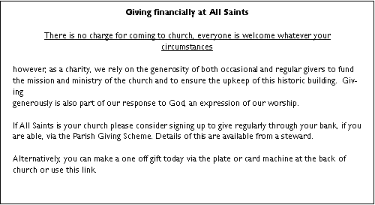

Taking of the Bread and Wine

Word made flesh, life of the world,
in your incarnation you embraced our poverty:
by your Spirit may we share in your riches.
Amen

The president washes their hands symbolising our desire to come together at the Lord’s table with pure hearts and minds.

The Eucharistic Prayer

The Lord be with you
And also with you

Lift up your hearts.
We lift them to the Lord.

Let us give thanks to the Lord our God.
It is right to give thanks and praise.

The president praises God for His mighty acts and all respond by singing (to the tune of the carol Infant Holy.)
The president recalls the Last Supper, we join in with the following response

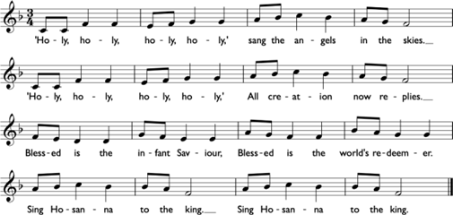

This is his/our story
This is our song: Hosanna in the highest

The prayer continues leading into the final words of praise

May we and all who share this food offer ourselves to live for you
and be welcomed at your feast in heaven
where all creation worships you,
Father, Son and Holy Spirit:
Blessing and honour and glory and power
be yours for ever and ever.
Amen

We kneel or sit and observe a moment of silence.

The Lord’s Prayer

We say this prayer together, each in whichever language is closest to our hearts. It may be led by a member of the congregation using one of the global languages that make up our intercultural community.

Rejoicing in the presence of God here among us, as our Saviour taught us, so we pray.

Our Father in heaven,
hallowed be your name,
your kingdom come,
your will be done,
on earth as in heaven.
Give us today our daily bread.
Forgive us our sins
as we forgive those who sin against us
Lead us not into temptation
but deliver us from evil.
For the kingdom, the power,
and the glory are yours
now and for ever.
Amen.

Breaking of the Bread

We break the bread of life, and that life is the light of the world.
God here among us, light in the midst of us,
bring us to light and life.

Giving of Communion

Christ is the true bread which has come down from heaven.
Lord, give us this bread always.

We sing together while the ministers and servers receive communion and the communion assistants come to the front.

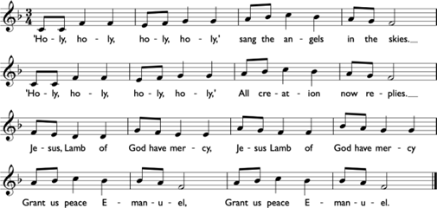
Please come forward when directed by the stewards. Christians of any church tradition are welcome to receive the bread and wine including children who have been admitted to communion, here or at another church. Alternatively you can come forward for a prayer of blessing, please indicate if this is your wish by crossing your arms across your chest.

As we share communion the choir may sing or music may be played. We all join in singing the communion hymn(s) that follow, the number(s) for which can be found on the notice sheet and on the hymn board at the front of church.

Prayer after Communion

A brief silence is kept. The president says the post communion prayer for the day.

The Dismissal

Notices

The Blessing

We stand for the president to give the blessing

May the joy of the angels,
the eagerness of the shepherds,
the perseverance of the wise men,
the obedience of Joseph and Mary,
and the peace of the Christ-child
be yours this Christmas;
and the blessing of God almighty,
the Father, the Son and the Holy Spirit,
be among you and remain with you always.
Amen

Final Hymn

As we sing our final hymn the servers and ministers process. Children are welcome to join the procession. Please turn to face the ministers for the dismissal.

Go in peace. Proclaim the Word made flesh.
Glory, thanks and praise to God.

Organ Voluntary

December 2025
office@allsaintsloughborough.org.uk

